# Design Patterns

## My top 3

* Creational – Factory Method
* Behavioural – Mediator
* Creational – Builder

## My Favourite

### Behavioural – Mediator

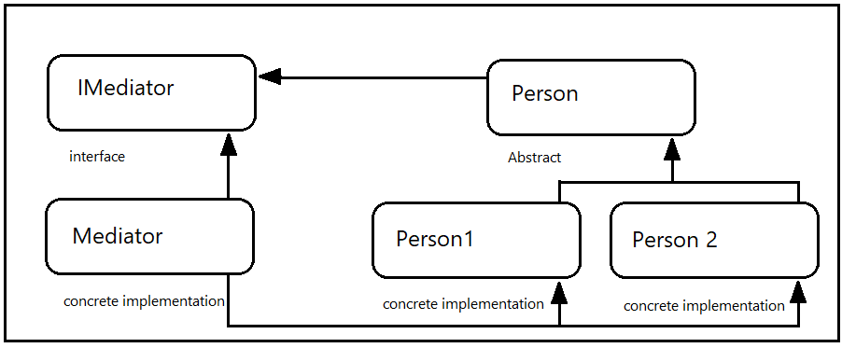

When there is a requirement to have peer-level objects that need to communicate with each other although tightly-coupled, we can easily set references to each object. When other objects are added to the mix then the need for joins exponentially increases and quickly becomes unwieldy.  
  
The Mediator pattern Removes most of the tight-coupling but also greatly reduces the connections between a large collection of objects by mediating those messages.